Eur-Danube Rider Votive Plaque-3rd c CE

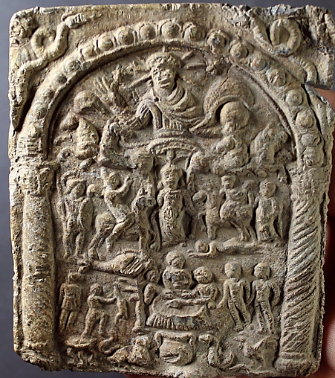

Danube Rider votive plaque  
  
Lead, diam. 92x77x3mm, rectangular in shape and cast in relief. This is a so-called mystery plaque, probably to be associated with Thracian or Dacian beliefs of the Lower Danube region. Two columns with Corinthian capitals and an arch frame the scene, possibly forming a sanctuary; on the outside, in the top corners of the plaque, two snakes can be seen.

Within the structure, we see sungod Sol in his quadriga (a chariot with four horses) in the first register, with a crown of rays around his head, holding a globe in his left hand; at both sides of his head, two stars are shown, which have been interpreted as possibly the morning star and the evening star.

Central in the second register is a woman or goddess. She is lifting her garment, forming a sack to feed of the horses. On either side of her we see the typical horsemen, greeting the goddess. The horses step on a fish (on the proper right hand side of the central figure) and a man lying on the ground (on her proper left hand side).

The third register contains in the middle a couple of men (possibly priests, because on many of these plaques they are depicted bold), grouped around a table with a fish (which has been explained as possibly an offering meal); there are other figures in the same register.

In the fourth register we see a tripod table with fish on it, a kantharos (a symbol for water), a lion (a symbol for fire), a snake (a symbol for the earth) and a rooster (a symbol for the air).

Roman Imperial, 3rd Century A.D.  
  
condition: attractive, minor encrustation, minor chamfered, otherwise intact with good clear detail  
  
Provenance: Collection of Professor Rudolf Franz Ertl. He published part of his collection of cult plaques in the book Donaureiter – Bleivotivtafeln. Versuch einer Typologie (Vienna, 1996).  
  
Compare a very similar item in the Metropolitan Museum / N.Y., retrievable also through internet (without quotation marks): Rogers Fund, 1921  Accession Number: 21.88.175